Exam 3: NE591-10: Nuclear Fuel Performance

1. The temperature and gap width of a fuel pellet, as predicted by a fuel performance code, is shown below. Using the plots as your guide, determine what is currently occurring within the cladding, gap and/or pellet at each number. Note that the numbers are at the same burnups on the two plots. (15 pts)

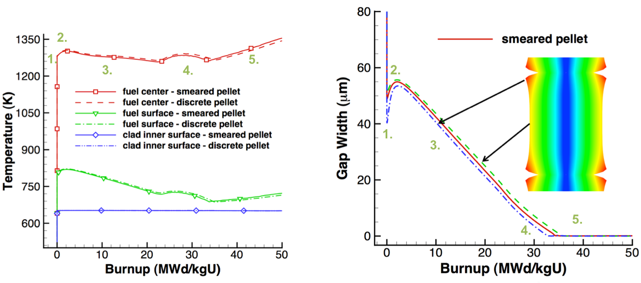

For each number (1-5), describe what is occurring in the cladding, gap, and pellet. Also, describe what features in the plots indicated these behaviors.

1. A fuel pellet with an average grain size of 8 microns is irradiated with a volumetric neutron flux of 2.0e13 fissions/(cm3-s). Assume the pellet is at a uniform temperature of 900°C.
2. What is the fission gas diffusion coefficient at this temperature? (5 pts)
3. How many gas atoms/cm3 are released from the fuel after 2 years of irradiation? Assume the yield y = 0.3017. (5 pts)
4. The pellet is removed from the reactor and from its cladding, venting all released gas. It is then moved to a furnace and annealed at 2000 °C. Estimate how long before 60% of the gas trapped in the pellet is released. Assume τ > π-2. (10 pts)
5. A ZIRLO cladding tube is in reactor at 600 K for one year. The initial wall thickness is 600 μm.
6. Estimate the oxide thickness after this time? (8 pts)
7. Assuming the hydrogen pickup fraction is 15%, what is the weight PPM of hydrogen in the cladding after one year? Assume PBR = 1.56, ρZr = 6.5 g/cc, ρZrO2 = 5.68 g/cc. (8 pts)
8. Determine the total change in the fuel volume given: αth=11x10-6, fission rate = 3.5x1013 fiss/cm3-s, T=1600 K, Tref=300 K, Δρ0=0.01, BD=5 MWD/kgU, ρ(UO2)=10.97 g/cc, t=85 days. (15 pts)
9. What are the five types of fission products that form in the fuel? (5 pts)
10. List the three stages of fission gas release. (6 pts)
11. Name two types of creep. Which type of creep is based on bulk diffusion? (5 pts)
12. What performance effects result from the High Burnup Structure? (6 pts)
13. Describe the concept of microstructure-based fuel performance modeling. (6 pts)
14. List three benefits of using Zr cladding. (5 pts)
15. Why does metallic fuel undergo constituent redistribution? (5 pts)
16. Why is the microstructure of U-Zr based fuels so varied and complex? (6 pts)